TANKING SLURRY

WATERPROOF CEMENT BASED COATING FOR
MASONRY AND CONCRETE

Construction Chemicals Tanking Slurry is a sophisticated cementitious formulation designed for use in below and above ground waterproofing situations. The product is made up of many components, which give high water resistance, flexibility, good adhesion and set control in a form that only requires water for mixing.

High Water Resistance
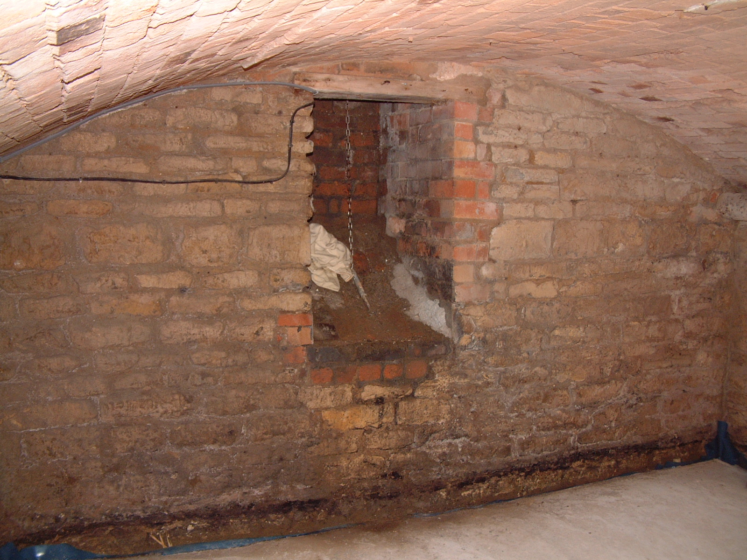

This is achieved by using a highly hydrophobic dispersible polymer

that reacts with the other components to give water resistance and

flexibility. The grading of the powders in the slurry means that a

very dense coating is produced. Particle sizes as low as 0.5 micron

ensure that every potential air space is filled with an impervious

sphere of water and chemical resistant material.

Flexibility

The polymer used is flexible and to improve this performance special

fibres are added which allow a much higher level of flexibility.
Turn old damp cellars into useful living areas with Tanking Slurry. Specification service on request

SALT RESISTANCE

The presence of salts in below ground situations can cause expansion when

drying and lead to de-lamination. Two components contained within Tanking Slurry actually react with these soluble salts turning them into solids that do not exhibit efflorescent or hygroscopic effects. In areas where salts may be a problem use Construction Chemicals Anti-Salt on the substrate before applying Tanking slurry.

GOOD ADHESION

Adhesion comes from the polymer and the presence of special cements, which bind the slurry cohesively and give good adhesion to masonry.

SET CONTROL

This is achieved by using rapid setting cements together with set accelerators. This ensures that even in areas where there may be water movement the slurry sets quickly whilst allowing a reasonable period for application. Where running water is experienced however, CC water seal must be used to control water flow whilst the slurry is curing. Construction Chemicals Tanking Slurry is manufactured to have to a high level of performance in any situation where lateral or penetrating dampness is found. It has been carefully formulated to ensure that it is not affected by the problems normally associated with water movement.

USES

Tanking slurry is used as a waterproofing membrane, which may be applied by brush or spray(USING SPECIALIST SPRAY EQUIPMENT). Where external ground level is above internal floor level it is usually necessary to provide a barrier to penetrating moisture in conjunction with an injected DPC. In such circumstances TANKING SLURRY may be applied directly onto the brickwork before DPC injection takes place. In cellars and other areas of high hydrostatic pressure and where there could be sulphate salts present, it is advisable to use a sulphate resistant (tight) backing coat before applying TANKING SLURRY.

- FOUNDATION SLABS
- SILAGE PITS
- PARTY WALLS
- AS A VERTICAL DPC IN STONE WALLS OR
WALLS OVER 250MM
- FISH TANKS (BLACK SLURRY AVAILABLE)
- LIFT SHAFTS

Areas of use include the following:

- CELLARS/BASEMENTS
- TANKS AND DUCTS
- UNDERGROUND CAR PARKS
- SWIMMING POOLS
- BUND WALLS

Units 1 & 2a Lazarus Court
Woodgate - Rothley
Leicester - LE7 7NR
TEL: 0116 230 1955 – FAX: 0116 230 1944
www.constructionchemicals.co.uk

DESCRIPTION

Tanking slurry is a blend of Portland cements, quality graded aggregates and chemical modifiers, which provide a waterproof coating system. The standard product is supplied in grey; other colours can be made on request. It also contains an acrylic polymer to assist bonding therefore reducing the use of SBR directly into the slurry.


ADVANTAGES

Excellent adhesion: Special mix design produces
stable adhesion to construction
surfaces.

Durable protection: Waterproof coating has long
life characteristics.

Water based: Safe to apply on damp surfaces.

Easy application: May be applied by brush or spray.

SPECIFICATION

Construction Chemicals Tanking Slurry should be used to
Stretton Hall on the border of Lincolnshire and Leicestershire, refurbished to a high standard using many of Construction Chemicals products. The cellars have been waterproofed using tanking slurry and have been converted into a gym, sauna and plunge pool.
form all coatings required for waterproofing purposes.
The product must be stored, handled and applied
strictly in accordance with the manufactures instructions.

APPLICATION/ PREPARATION

Preparation
All contact surfaces must be clean and sound. Remove all loose materiel, laitence, dust and any previous coating. Tap off water pressure where necessary, insert a fillet at floor and wall joint (see page 4 individual specification). Repair any existing cracks and fractures with Construction Chemicals Rapid Cement.

SERVICES

Seal around all services and pipes with CONSTRUCTION CHEMICALS PRO-BOND 2000 MS POLYMER

PRIMING

Under normal applications no priming is required; however you should refer to the individual specification that may be provided by your Technical Representative. On dry surfaces the background should be dampened to assist the coating in fully wetting out.

MIXING

The water requirement to produce the coating is 5.5 to 6.5 litres of water per 25 kg of dry material. Pour the required quantity of water into suitable mixing vessel. Slowly add the powder to the water whilst continuously mixing. Mechanical mixing is recommended using a slow speed high torque drill with a plastering paddle. Mixing should be continued for three minutes after all the powder has been added to the mixing water to obtain a “creamy” consistency.

COATING

Construction Chemicals Tanking Slurry is applied in two coats (except above ground, see individual specification) the first coat in a horizontal direction down to fillet level. Apply second coat at right angles to the first as this will ensure complete coverage of the substrate. Second coat can be applied before
the first is dry providing the first does not drag. In some cases a tight coat of render made up of 3:1 sand cement mix, using a sulphate resistant cement and SBR mixed at 1part SBR 3 parts water as gauging may
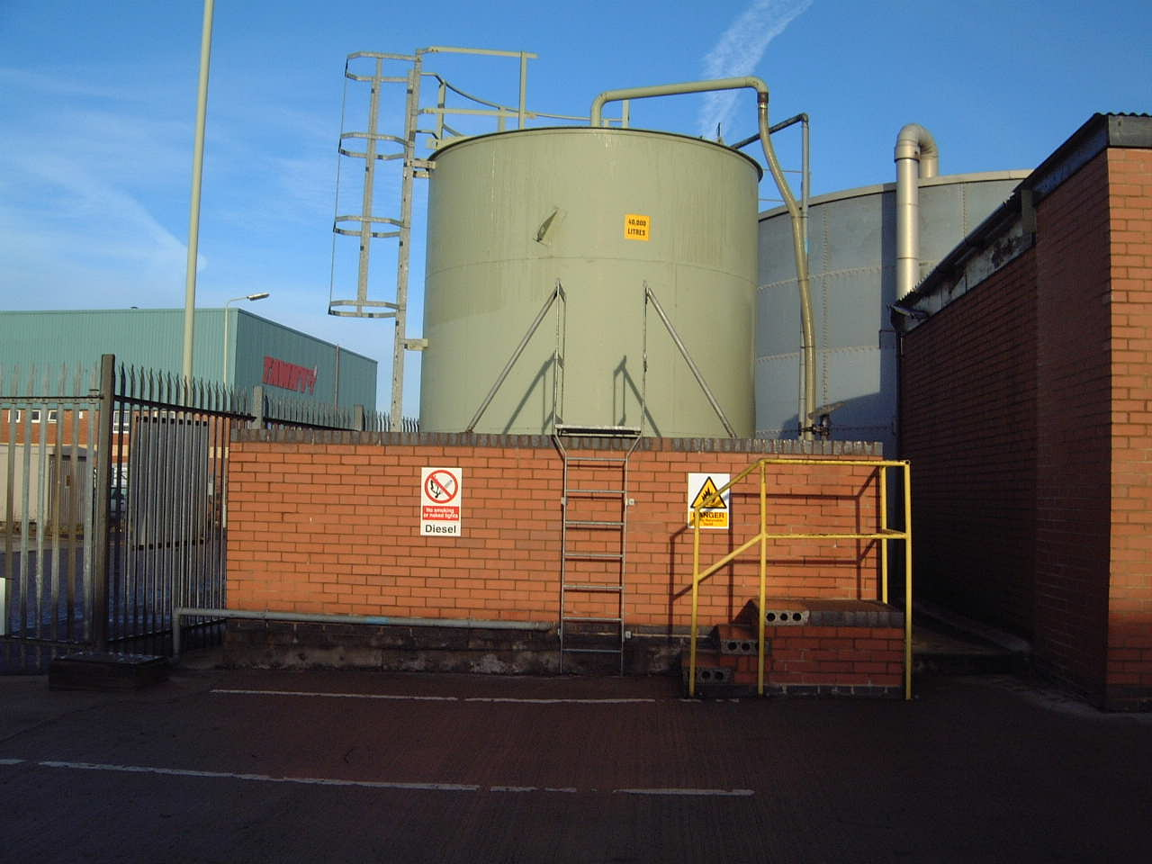
be required, refer to your individual specification or our technical dept if
you are unsure.

N.B.

Do not re-temper stiffened material. Tanking Slurry
should not be applied in frost conditions or to frost filled
surfaces or when temperature is 5 deg C and falling.

Tanking slurry is chemical resistant and ideal for bund walls.

CURING

In warm or windy conditions mist spraying may be used to compensate for moisture loss. In tanking applications a through flow of air is required to prevent condensation. Tanking Slurry has an initial set time of 30 minutes and can be over coated after this time dependant on temperature and ventilation. Tanking slurry can be rendered after 24 hours when tanking is fully cured. Render coat should contain SBR to assist bonding and floor coatings should be screeded or sealed with an abrasion resistant coating such as Construction Chemicals levelling compound or Multi Use Water Based Epoxy Coating. Protect from frost, direct sunlight, and drying winds for 24 hours.

PRECAUTIONS

Health and Safety
Tanking Slurry is alkaline when mixed with water and should not come into contact with skin or eyes. Avoid inhalation of dust during mixing and wear safety glasses, dust mask and cloves. If skin contact occurs wash with clean water. Should eye contact occur rinse immediately with plenty of clean water and seek medical advice. For full health and safety data refer to Product Safety Data Sheet.


FIRE

Tanking slurry is not a fire risk

COVERAGE
MIXING RATIO 5.5 to 6.5ltr water per 25kg unit.

The coverage will depend on the substrate surface.
Course surface – 2kg to per square metre per coat
Kair ventilation systems should be considered on cellar conversions due to the risk of condensation.
Smooth surface - 2kg to 2.5kg per square metre per coat

Initial set: 30 minutes

STORAGE AND SHELF LIFE

Tanking slurry will have a shelf life of six months in bags. Store in dry conditions at temperatures above 5 deg C.
TANKING AND SBR USAGE CHART

SQ MTR | 10 | 15 | 20 | 30 | 35 | 40 | 45 | 50 | 55 | 60 | 65 | 70
ABOVE  GROUND KG | 20 | 30 | 40 | 60 | 70 | 80 | 90 | 100 | 110 | 120 | 130 | 140
SBR 5L | 1 | 1 | 1 | 2 | 2 | 2 | 3 | 3 | 3 | 4 | 4 | 4
BELOW GROUND KG | 40 | 60 | 80 | 120 | 140 | 160 | 180 | 200 | 220 | 240 | 260 | 280
SBR 5L  PRIMER  SLURRY | 2 | 2 | 2 | 4 | 4 | 4 | 5 | 5 | 5 | 6 | 6 | 6
SBR 5L  TIGHT COAT | 4 | 4 | 4 | 6 | 6 | 6 | 8 | 8 | 8 | 10 | 10 | 10

FLOOR AND WALL JOINT DETAIL

INSTALLATION OF FILLET SEAL

- If specified apply a tight coat of render to level surface with 3;1 sand cement mix, use SBR 1 part to 3 of water as gauging, use sulphate resistant cement. Or Apply priming coat if specified
- Apply first coat of Tanking Slurry.
- Insert 25mm fillet to floor/ wall or wall/ wall joint.
- Apply second coat of Tanking slurry

1

4

3

2

FIXING DETAIL

1
TANKING COAT

1
2
OVERSIZED HOLE PLUGGED WITH WATER SEAL

3
FIXING PLUG


Where fixings have to be made, provisions should be made in advance by drilling oversized holes and plugging with CONSTRUCTION CHEMICALS WATERSEAL, then insert a fixing plug whilst the water seal is still soft, alternatively wait till the waterseal has cured then drill the correct size hole.

Skirtings and dado rails should be glued using Construction Chemicals Panel Adhesive

THE INFORMATION GIVEN IN THIS DOCUMENT DOES NOT CONSTITUTE A SPECIFICATION

Updated 08 10 18

