

ENVIRO-SAFE FACADE WATER REPELLENT
MICROPOROUS WATER REPELLENT FACADE PROTECTION

DESCRIPTION

Enviro-Safe Facade Water Repellent is an effective water repellent liquid based on a solvent free silicone/siloxane emulsion for use above ground on porous brickwork, cement renderings, asbestos, cement/mineral boards, unglazed tiles, cast concrete, roughcast stonework (including calcareous materials, ie those containing limestone), wood, canvas and leather. Surfaces treated with Enviro-Safe Facade Water Repellent remain permeable to vapour so that moisture within the structure does not remain trapped.

Enviro-Safe Facade Water Repellent is clear and colourless and will not normally alter the appearance of treated surfaces. The treated masonry surface will not prevent the penetration of water at pressures greater than approx 1.4kg.cm2 (20lbs per square inch).

Note: - Enviro-Safe Facade Water Repellent is not a dust proofing sealer or damp-proofing membrane.

General Information

Penetrating damp causes damp patches on exterior wall surfaces and in more serious cases on interior walls. This is caused by differences in the capillary absorption of masonry. Faulty damage can be caused such as wall tie corrosion and other structural damp.

Damage to the surface layer of the masonry (spalling) can be caused by the effects of frost damage. Water in the wall expands by 10% when it freezes setting up high pressures on the pore structure causing this problem.

Unsightly moss and mould growth can also occur on the surface, this will only occur on a wet surface.

Unsightly, generally white salts (efflorescence) can show themselves on the surface. There are water soluble salts in the masonry that are partially dissolved by the water and carried to the outside during drying forming crystals on the exterior surface. These salts dissolve when it rains again.

Heat loss through a wet wall is up to 3 times higher than through a dry wall. A wet wall is a cold wall and thermal insulation values are relative to the dampness of the wall.

Treatment with Enviro-Safe Facade Water Repellent can help to prevent the accumulation of dirt on an exterior surface improving the visual effect of the property.
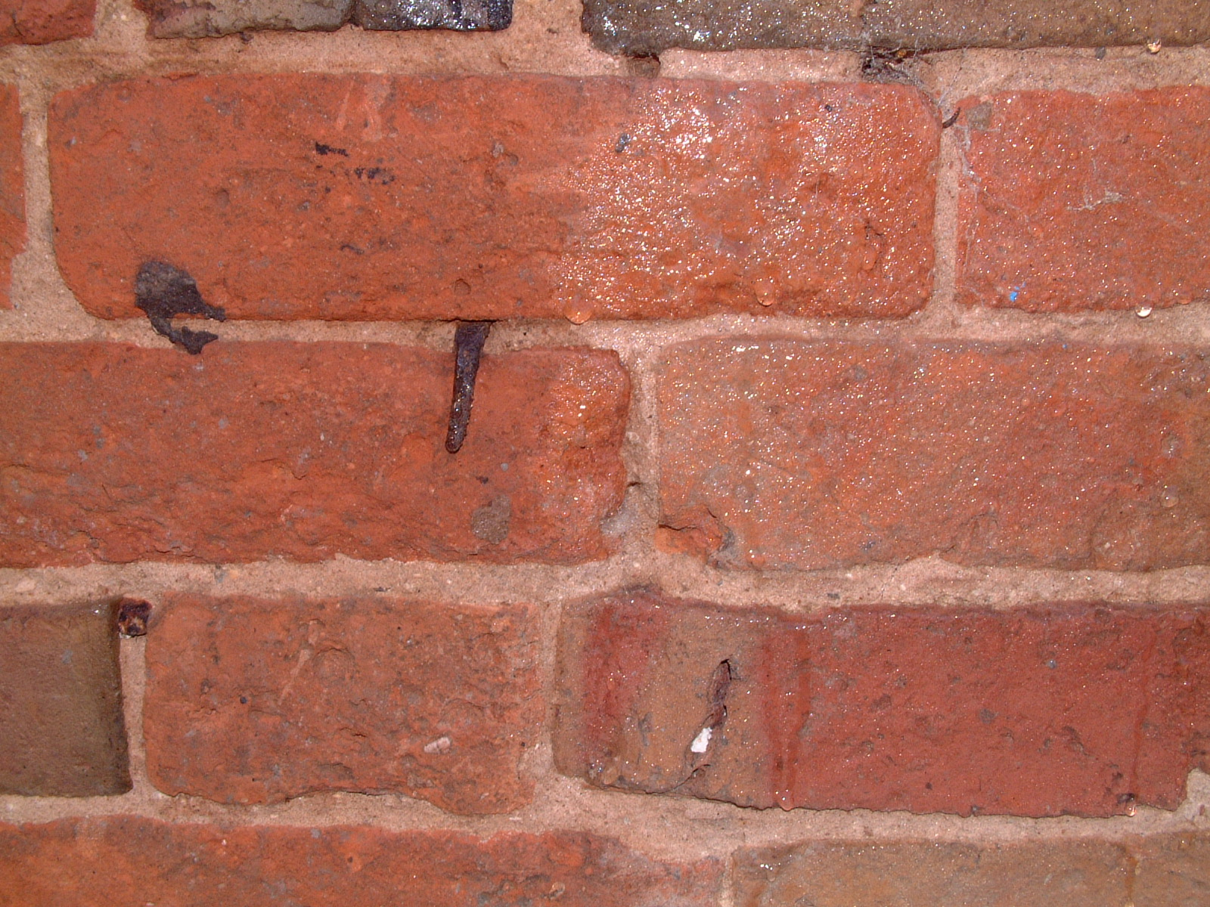

Buildings can be damage by the effects of acid rain. Chemicals in the atmosphere
are absorbed by the rian and carried into masonry causing damage.

SPECIAL PROPERTIES

- Deep penetration
- High resistance to ALKALIS
- Rapid development of water repellency
This picture clearly shows areas treated with Façade water repellent.
- Provides good adhesion for paints
- Water based
- Stable in store, even when diluted.

Enviro-Safe Facade Water Repellent reduces the capillary absorption of the building which it has penetrated, but does not clog the pores or capillaries. There is no impairment of the building materials ability to ‘breathe’.

Units 1 & 2a Lazarus Court
Woodgate - Rothley
Leicester - LE7 7NR
TEL: 0116 216 5354
www.constructionchemicals.co.uk

APPLICATION

The success or failure of Enviro-Safe Facade Water Repellent depends on applying sufficient solution in a uniform coating to the surface. The treatment can be applied by various methods including brush, lambs wool roller or coarse spray.

Treatment should start at the highest point working from side to side whilst allowing a ‘Run-Down’ of up to 300mm. Poorly absorbent dense surfaces will require one application. High absorbent surfaces are recommended to have two flood coats applied wet to wet.

PREPARATION

Substrates should be prepared by cleaning to remove all surface containments, including fungal/mould growths. Mould release agents or decorative paints should be removed completely. Structural defects, particularly mortar joints, re-pointing or rendering must be made good and allowed to cure for at least 1 month before treatment Enviro-Safe Facade Water Repellent will not prevent ingress of water through cracks or defective joints.

Where backings are heavily contaminated with salts, there is an increased risk of spalling of surfaces treated with water repellents. The application of Construction Chemicals Water Repellents is not recommended under these circumstances, if doubt exists; seek advice from our Technical Department.

Protect surfaces liable to be splashed during treatment, especially glass window panes, UPVC window frames and decorative coatings. In exceptional circumstances a further coat may be necessary. Allow at least 2 hours between coats and do not apply to surfaces affected by rain or frost.
COVERAGE

Coverage will depend upon the porosity of the surfaces to
be treated. Average consumption is a 4-5m2 per litre per coat;
this may be reduced to 2m2 per litre on highly absorbent surfaces.

EFFECTIVENESS
If you want to avoid damage like this then specify Envirosafe Façade Water repellent.
Enviro-Safe Facade Water Repellent will become effective through
moisture evaporation. Initial surface cure (bleeding) can occur within
as little as one hour under good drying conditions, but cold
temperature, limited air movement and substrate moisture may all
extend the time taken for surface water repellency to develop.

The depth of penetration will depend on the type of substrate and moisture content, but will generally be between 4-6mm.

Treated surfaces will remain permeable to water vapour since the rate of evaporation is not retarded allowing the surface to ‘breathe’.

PACKAGING

2 Litre Concentrate
(makes 25 litres ready for use)

CONSUMPTION

4-5m2 per litre on dense substrates
2-3M2 per litre on porous substrate per coat

Target coverage rates should be 2-4 litres/M2 per coat

